- Purpose

The purpose of this procedure is to outline the steps necessary to perform maintenance on the Dehumidification System on a periodic basis.

- Scope

This procedure applies to the Dehumidification System at the Manufacturing Facility. This procedure shall be performed as needed or outlined in the procedure.

- Responsibility

Maintenance Personnel

- Safety Considerations

Safety glasses and appropriate safety apparel are to be worn at all times.

Safety is a condition of employment. Employees are not authorized to work in an unsafe manner and are prohibited from harming the environment of the facility or community.

- Materials/Equipment

- Tools necessary for performing maintenance
- Lock
- Tag
- Lock out device

6.0 Procedure

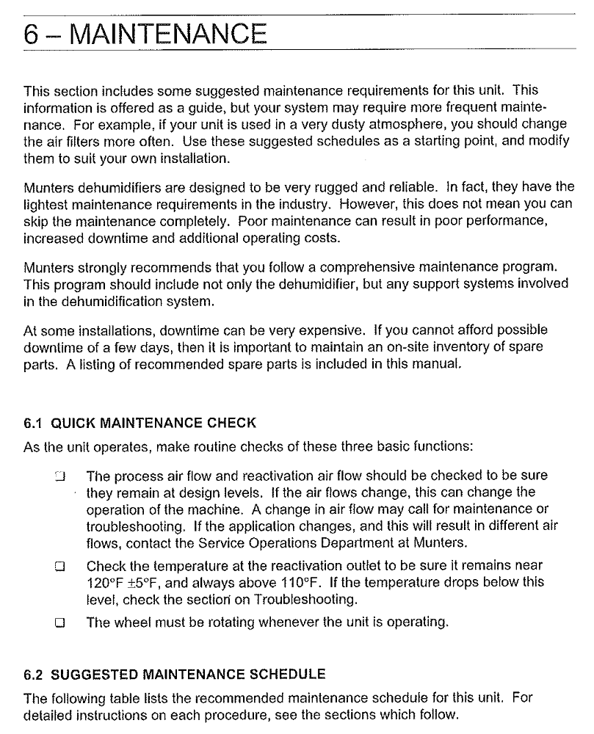

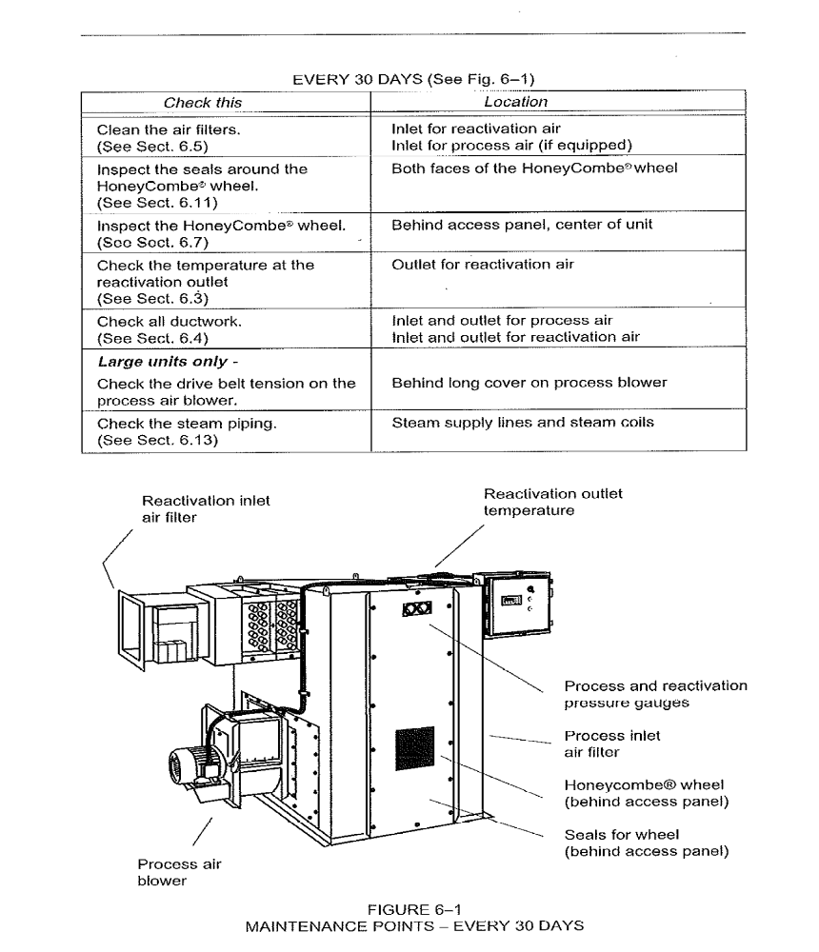
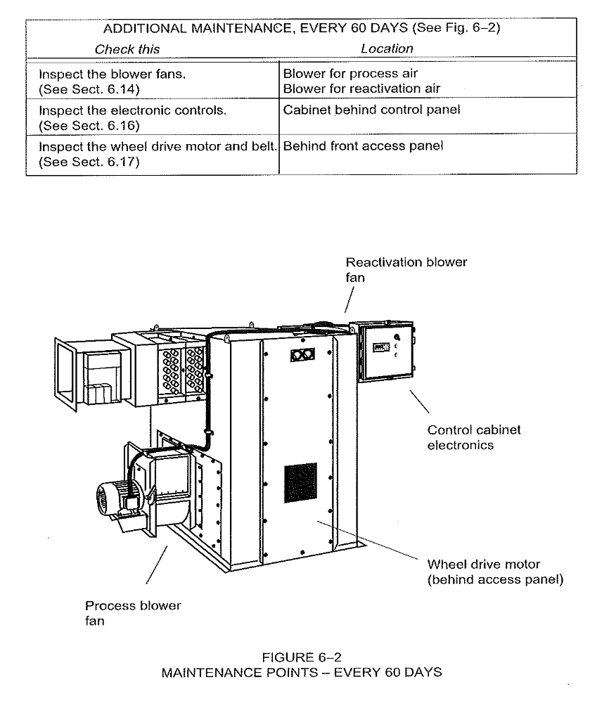
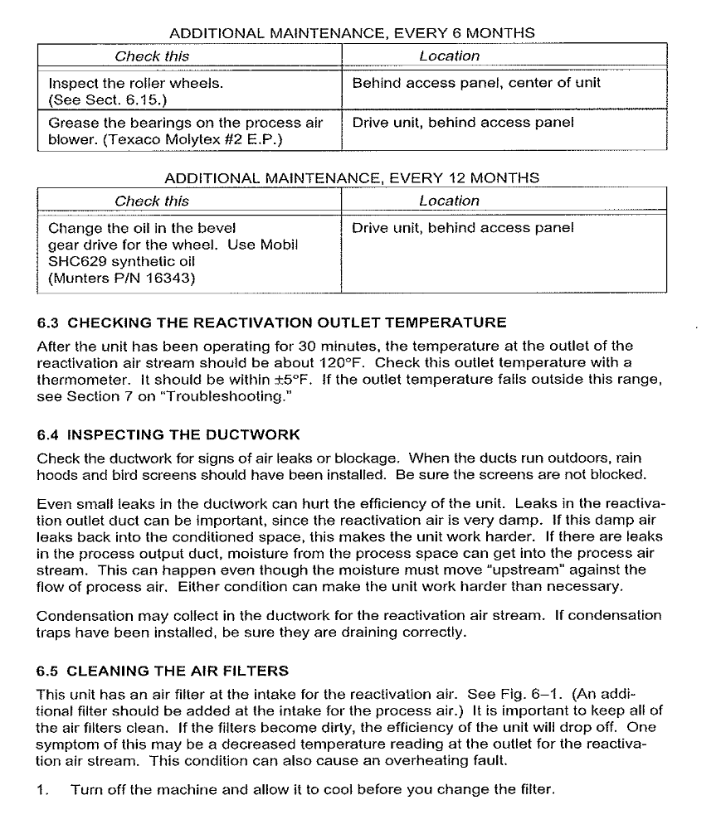
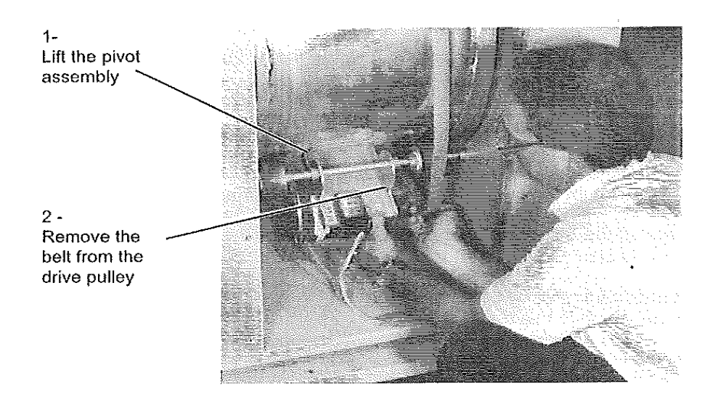
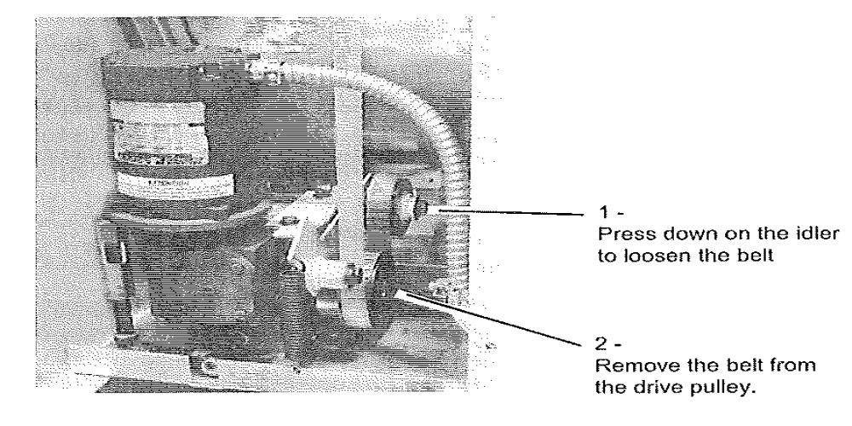

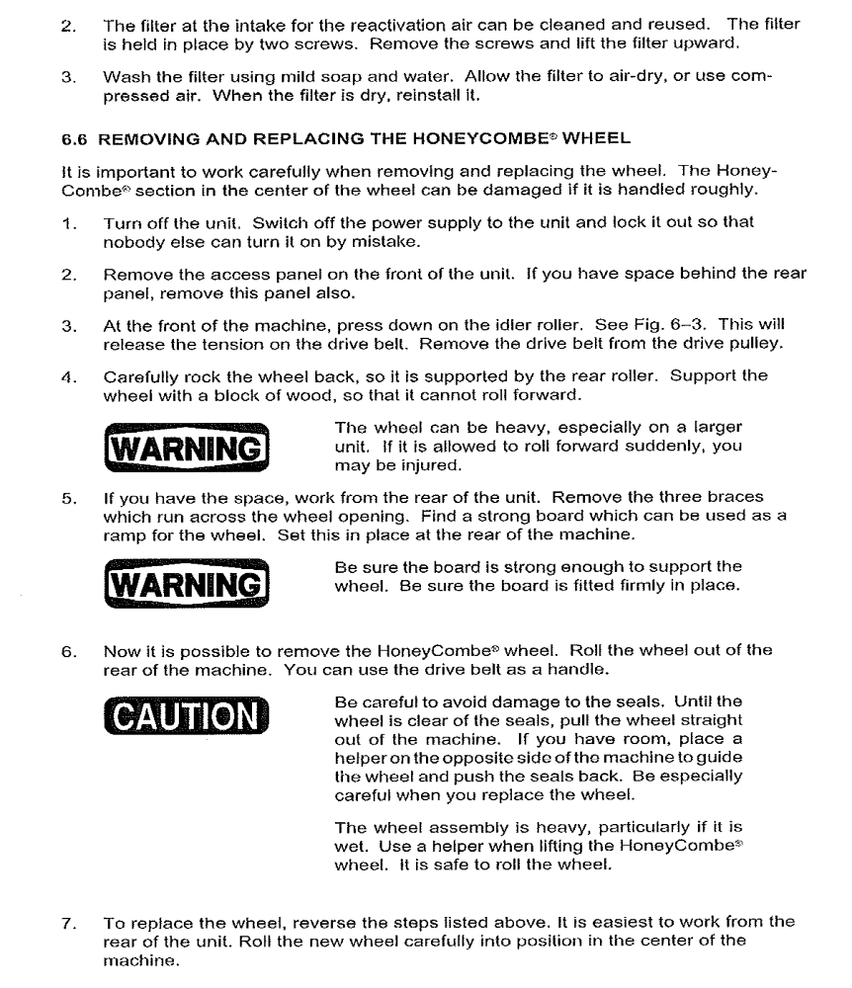
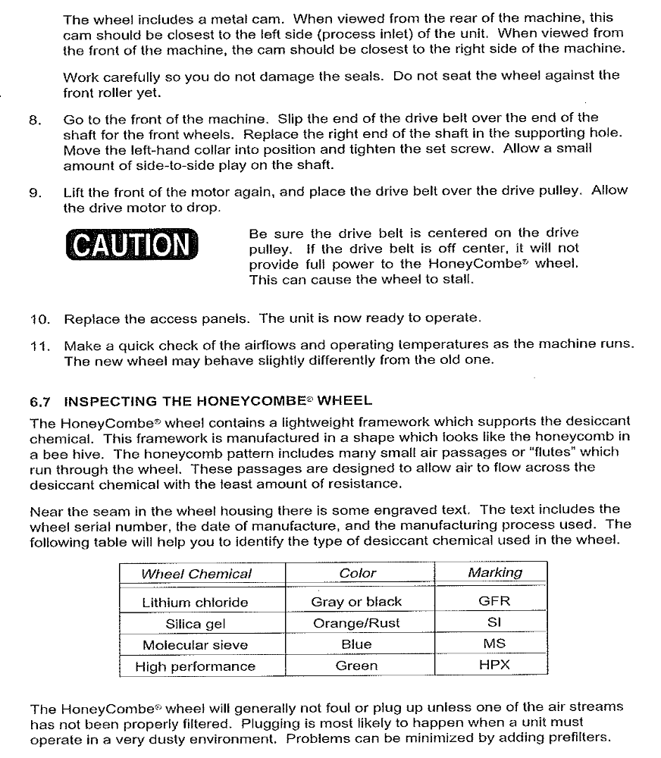
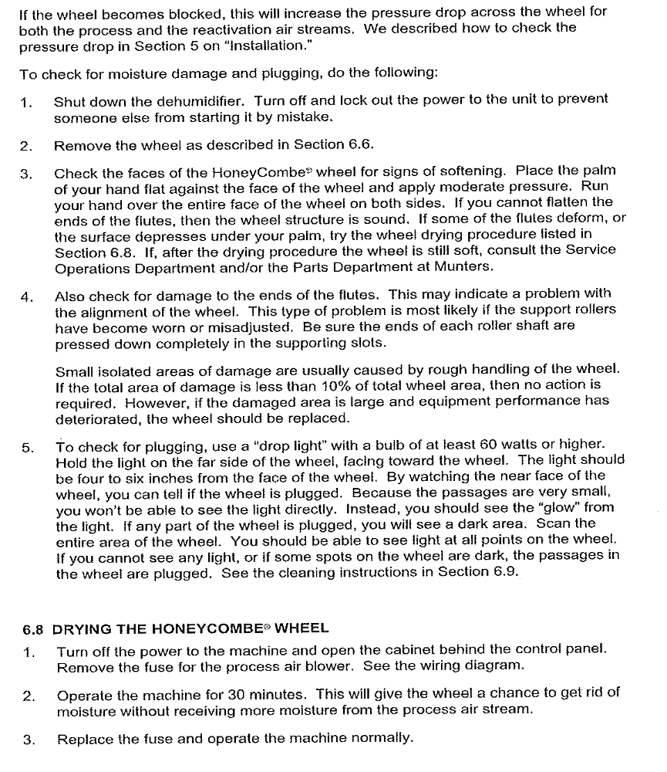
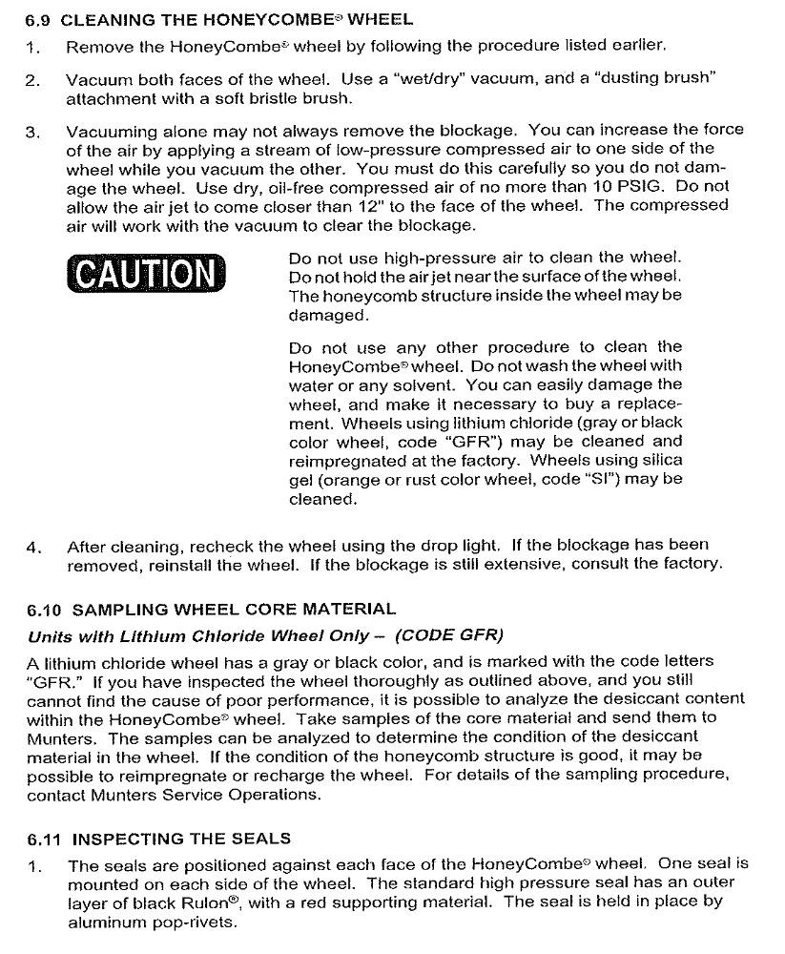
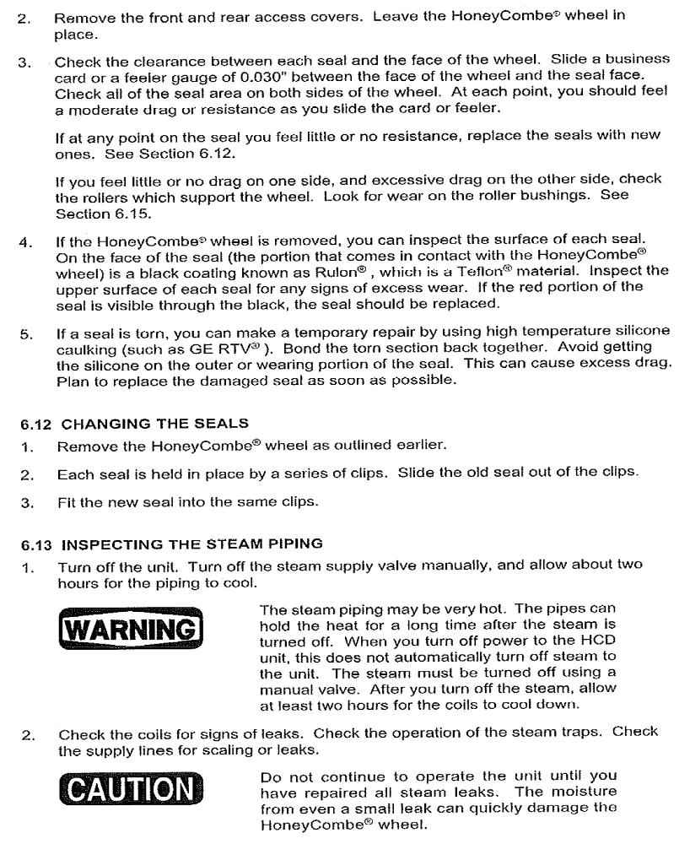
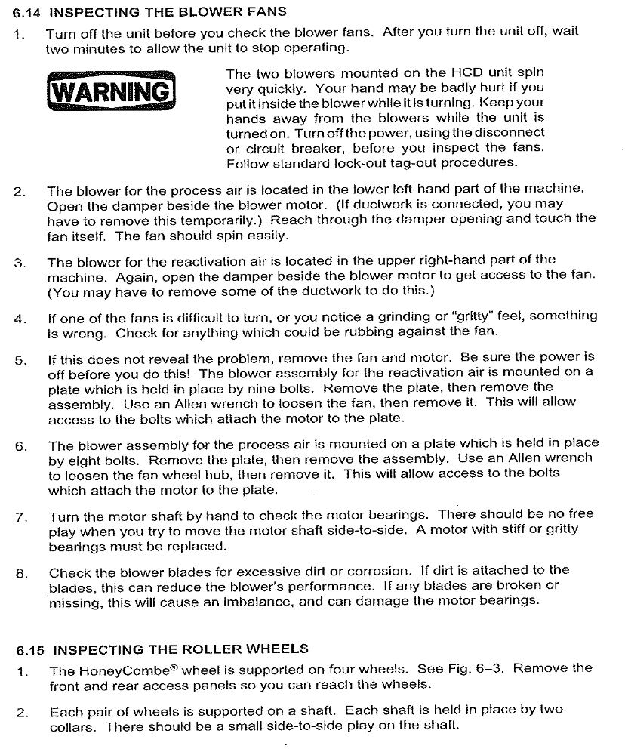
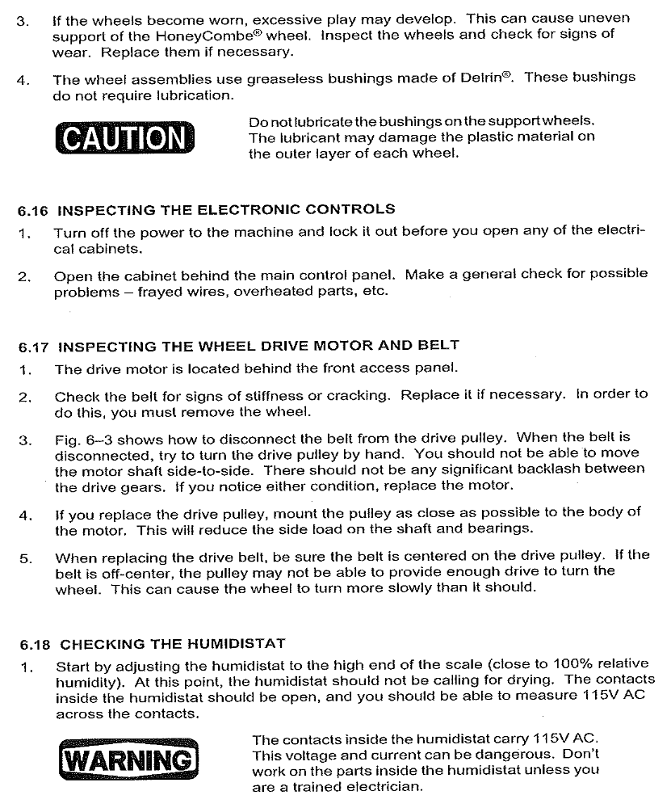
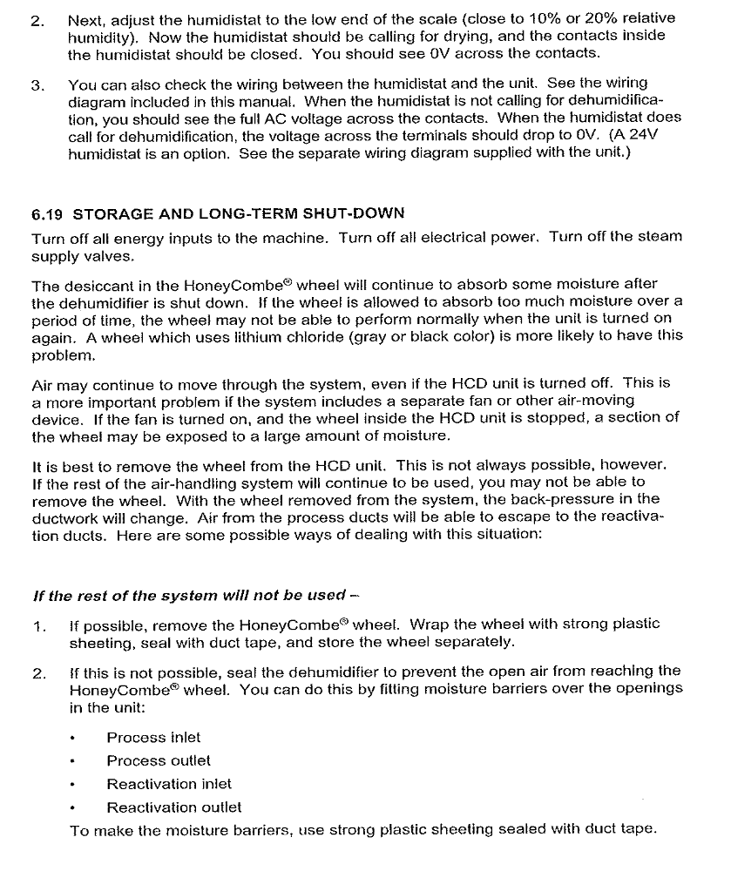
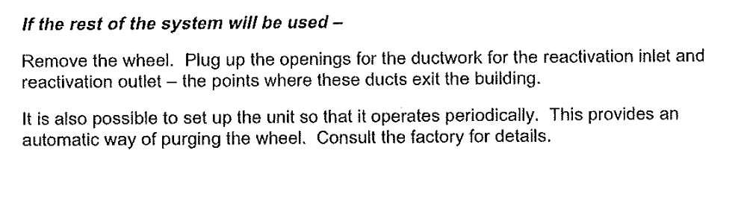
- Reference Documents

N/A

- Change Information

New Document

